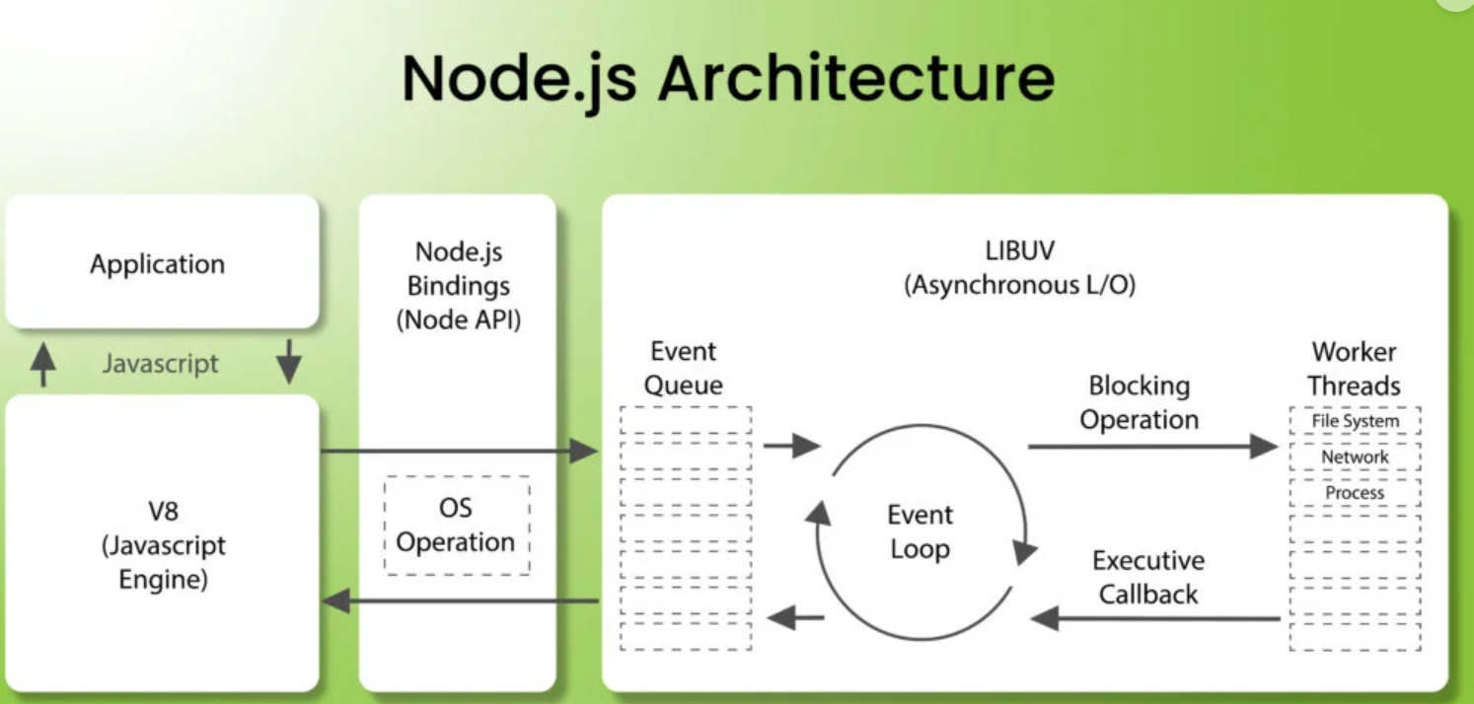

Node.js operates on a single-threaded, non-blocking architecture that allows it to efficiently handle both synchronous and asynchronous operations. When a Node.js application starts, the V8 engine executes the JavaScript code, processing synchronous tasks one by one.

Asynchronous tasks, on the other hand, are delegated to Node.js’s asynchronous APIs, which serve as a bridge between the JavaScript code and the underlying system’s capabilities. Once an asynchronous task is initiated, it is handed off to libuv, a library responsible for managing these tasks.

While libuv handles the asynchronous operations, the main thread remains available to continue processing other tasks. Once an asynchronous operation is complete, the result is passed back to libuv, which adds it to the Event Queue. The Event Loop continually checks the queue for tasks and, when it detects one, it executes the associated callback function in the main thread.

This approach allows Node.js to efficiently handle multiple tasks concurrently without blocking the execution of others. For functions like setTimeout, the delay runs in the background, and once the specified time has passed, the callback is added to the Event Queue and processed by the Event Loop, keeping the application responsive.

Advantages

Scalability: Node.js is designed to handle large numbers of simultaneous connections with high throughput, making it ideal for scalable applications like real-time apps or microservices.

Non-blocking I/O: Its non-blocking, event-driven architecture ensures that Node.js can perform I/O operations without waiting for them to complete, increasing overall application efficiency.

Unified JavaScript: Since both server-side and client-side code can be written in JavaScript, developers can work across the entire stack without needing to learn multiple languages.

Fast Performance: Node.js leverages the V8 engine, which compiles JavaScript to machine code, resulting in faster execution of code.

Real-time Capabilities: With libraries like Socket.io, Node.js excels at handling real-time communication, such as chat apps, live notifications, or multiplayer games.

Community Support: Node.js has a large, active community contributing to open-source projects, which helps developers solve problems quickly and access a wealth of resources.

Cross-platform Development: Node.js applications can run on various platforms, including Windows, macOS, and Linux, without requiring significant changes to the codebase.